October 1st, 2022

Dianne Nubla

Rogers Communication Center

80 Gould Street

Toronto, ON M5B 2M7

Dear Dianne Nubla,

Thank you for showing interest in our latest green technology. My name is Hamza Malik, and as a Senior Engineer for Bike Share Toronto, I intend to give you a thorough overview of our Electric Bikes, their benefits, and solutions to their safety concerns.

**What Are Electric Bikes?**

Electric bikes, otherwise known as e-bikes, are pedal-assisted bicycles designed with a battery, motor, and sensors to make rides faster and more reliable (Victoria Sinclair, 2020). The concept of electric bikes has become an ideal alternative for the transportation industry in the city of Toronto, enabling residents to reach their destinations faster and more efficiently (SmartEtailing​​ Inc, 2021). Electric assist is automatically activated when a cyclist pedals, unlocking all features of our e-bike shown in Figure 1, allowing riders to select from various power levels reaching speeds of 25 kilometres per hour (E-Bikes, 2022). According to recent reports on greenhouse gas emissions in Toronto, transportation accounted for 73% of all emissions generating approximately 4.5 million Tons of CO₂ emissions in 2019 (Toronto’s 2019 Greenhouse Gas Emissions Inventory, 2019). In response, Bike Share Toronto launched a "Four Year Growth Plan" expanding from 625 to 1,000 stations and 10,000 bikes by 2025 to improve transportation reliability, reduce carbon footprint, and improve traffic flow (BikeShareToronto, 2022).

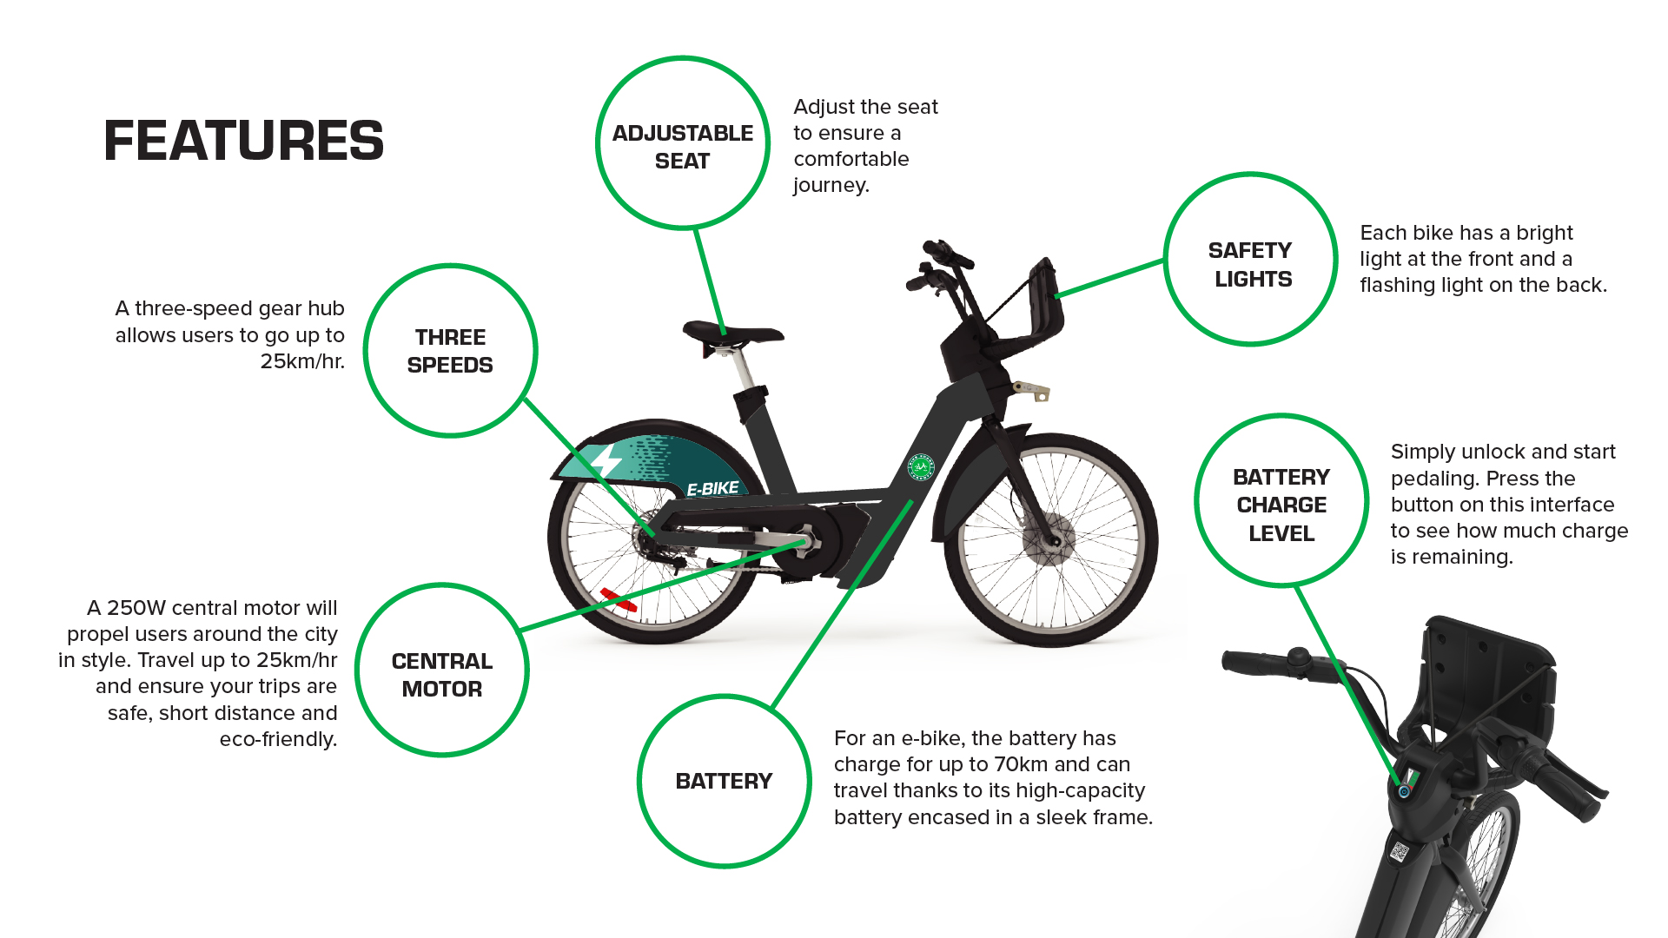

**Figure 1.** Features of Bike Share Toronto E-Bikes (E-Bikes, 2022**)**

**What Are the Benefits of Electric Bikes?**

The benefits of having electric bikes in Toronto can be summarized below:

* **Fitter Physical Health:** Although electric bikes take less effort to ride, a study conducted by Brigham Young University found that they provide excellent cardiovascular exercise, nearly as much as mountain bikes, without feeling pressured. Calories are still burned, regardless of pedal assist (Benefits of E-bikes, 2022).
* **Better Alternative to Cars:** The speed limit for vehicles in Toronto is usually 50km/h but often falls below 20km/h (Speed Limit Reductions, 2019), making e-bikes a better alternative (Crystal Daly, 2021). Toronto plans to create more bike lanes throughout the city, making it reliable for residents (ActiveTO - Expanding the Cycling Network, 2020).
* **Faster Speeds:** E-bikes offer riders a boost of up to 25km/h. It helps with hills, inclines, and rough terrain, allowing for a long smooth ride without physical exhaustion (Benefits of E-bikes, 2022)
* **Easier to Manage:** There are no requirements for e-bikes to be registered, have license plates, or get insured(Amego Electric Vehicles, 2020). In addition, there is no need to pay for expensive parking in Toronto; our e-bikes can be parked at any of the 625 available stations with an open dock (E-Bikes, 2022).

Despite concerns that e-bikes become a hassle when the battery dies or that helmets are required but not provided, it is far easier to carry a helmet than a $347 bill for parking each month in Toronto (Spot Hero, n.d). We offer docking stations where bikes are stored and borrowed; under our Growth Plan in figure 2, more bikes will be available for riders all over Toronto (E-Bikes, 2022**).**

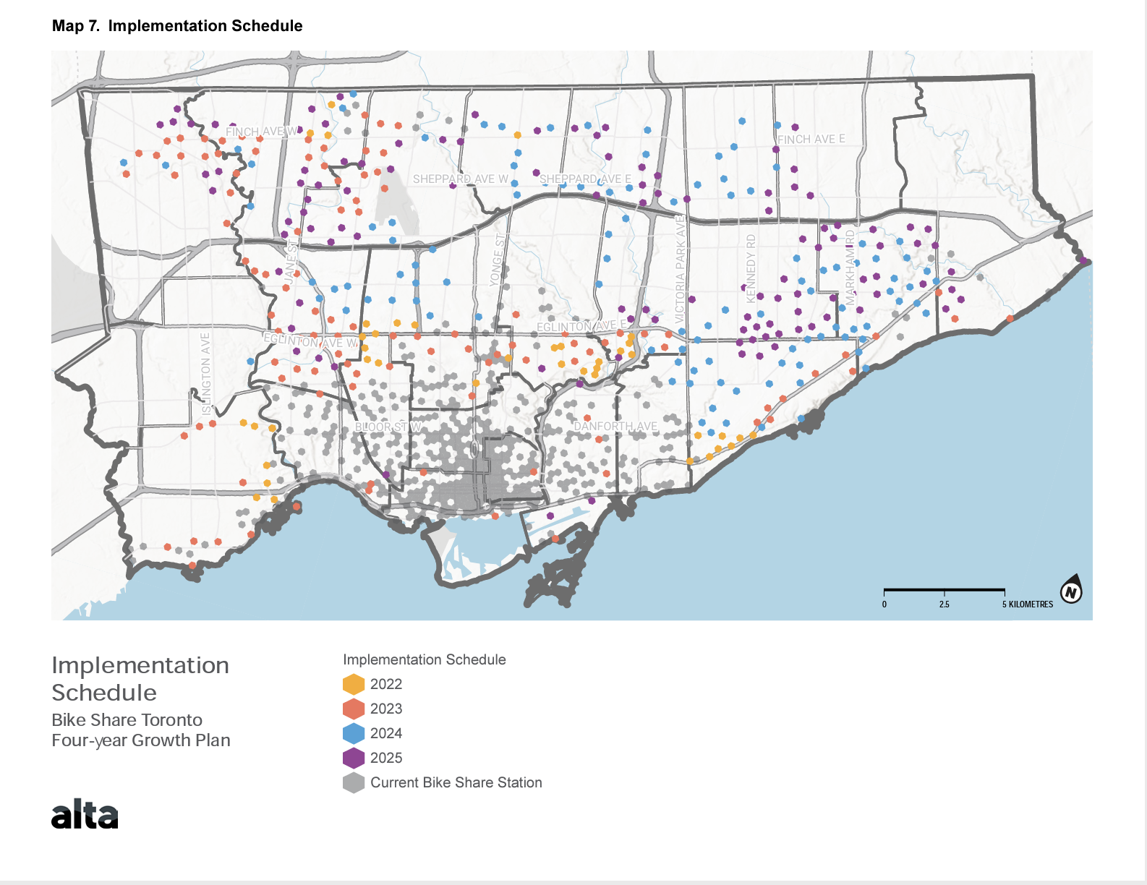

**Figure 2.** The Four-Year Growth Plan for Bike Share Toronto (BikeShareToronto, 2022).

**What Are The Safety Considerations of Electric Bikes?**

Despite their concerns, electric bikes have safety considerations outlined below:

**Table 1: Safety Considerations for Electric Bikes**

| **Solutions** | **Descriptions** |
| --- | --- |
| Solution #1:  Practice Mounts and Dismounts | Mounting and dismounting electric bikes can be challenging due to mobility issues and weak physical strength. To avoid severe injuries, take your time and adequately release the kickstand (Epic Cycles, 2019). |
| Solution #2:  Observe Traffic flow more Closely | While passing through your route, always keep an eye on traffic flow since e-bike riders travel faster, being alert and active is always essential. It enables you to react faster to traffic issues; You can counteract the ignorance of drivers who are unaware of the capabilities of e-bikes by paying close attention and avoiding distractions (Epic Cycles, 2019). |
| Solution #3:  Understand the Law | Although electric bicycle riders don't need any permits or licenses to operate, A cyclist must be at least 16 years old in Toronto and wear a safety-approved helmet. The city of Toronto allows cyclists to ride anywhere they want except on sidewalks, which are intended for pedestrians to walk on (Electric Bicycles (E-Bikes) & E-Scooters, 2022). |

Electric bikes' benefits and safety considerations make them an excellent addition to Toronto's green transportation sector. For further information, please contact me at +1855-898-2378 ext. 9924 or via email at questions@bikesharetoronto.gc.ca. Thank you for your questions.

Sincerely,



______

Hamza Malik

Senior Engineer

**Citations:**

ActiveTO - Expanding the Cycling Network. (2020, June 26). Retrieved October 1, 2022, from <https://www.toronto.ca/explore-enjoy/recreation/activeto/activeto-expanding-the-cycling-network/#:~:text=The%20Council%2Dapproved%20plan%20is>

Amego Electric Vehicles. (2020, December 31). Benefits of Using Electric Bikes and its Impact on one’s Wellbeing! Retrieved October 1, 2022, from <https://www.amegoev.com/blogs/latest-news/benefits-of-using-electric-bikes-and-its-impact-on/>

A performance evaluation. (n.d.). Retrieved October 1, 2022, from <https://www.site.uottawa.ca/~rhabash/Project-bicycles.pdf>

Authority, T. (2022). Retrieved October 1, 2022, from <https://parking.greenp.com/app/uploads/2022/09/BikeShareToronto_FYGP_wAppendix.pdf>

Benefits of E-bikes. (2022). Retrieved October 1, 2022, from <https://www.markelinsurance.com/resources/bicycle/benefits-of-e-bikes>

Bicycle pocket guide. (n.d.). Retrieved October 1, 2022, from <https://www.gazellebikes.com/media/gene-cms/p/g/pg_2021_usa.pdf>

BikeShareToronto_FYGP_wAppendix. (2022). Retrieved October 1, 2022, from <https://parking.greenp.com/app/uploads/2022/09/BikeShareToronto_FYGP_wAppendix.pdf>

​​Crystal Daly. (2021, May 13). Why Every Torontonian Should Own an Electric Bike. Retrieved October 1, 2022, from <https://scooteretti.com/blogs/news/why-every-torontonian-should-own-an-electric-bike#:~:text=Biking%20is%20Much%20Cleaner%20and%20Healthier&text=This%20is%20why%20it%20is>

E-Bikes. (2022, September 13). Retrieved September 30, 2022, from <https://bikesharetoronto.com/e-bikes/>

Electric Bicycles (E-Bikes) & E-Scooters. (2022, June 16). Retrieved October 2, 2022, from <https://www.toronto.ca/services-payments/streets-parking-transportation/cycling-in-toronto/cycling-and-the-law/electric-bicycles-e-bikes-e-scooters/#:~:text=While%20a%20drivers>

Epic Cycles. (2019, July 19). Using an E-bike in Canada: Safety Tips and Precautions. Retrieved October 2, 2022, from <https://epiccycles.ca/using-e-bike-canada-safety-tips-precautions/>

Grin Technologies Basics Ebike Guide. (n.d.). Retrieved October 2, 2022, from <https://planning.ubc.ca/sites/default/files/2019-11/DOC_UBC_Transportation_Cycling_EBikeBasicsGuide.pdf>

How Do Electric Bikes Work? (n.d.). Retrieved October 1, 2022, from <https://www.juicedbikes.com/blogs/news/how-do-electric-bikes-work#:~:text=How%20Does%20an%20Electric%20Bike>

​​How to Choose an Electric Bike | REI Co-op. (n.d.). Retrieved October 2, 2022, from <https://www.rei.com/learn/expert-advice/how-to-choose-an-ebike.html#:~:text=Understanding%20the%20Three%20Classes%20of%20Electric%20Bikes&text=Class%201%3A%20The%20motor%20kicks>

Inc, S. (n.d.). Electric Bike Toronto | Your Ultimate Ebike Guide - Sweet Pete’s Bike Shop Toronto. Retrieved October 1, 2022, from <https://www.sweetpetes.com/about/electric-bikes-guide-the-best-e-bikes-for-commuting-emtb-pg290.htm#:~:text=Ebikes%20can%20help%20you%20ride>

Kazemzadeh, K., & Ronchi, E. (2021). From bike to electric bike level-of-service. Transport Reviews, 1–26. <https://doi.org/10.1080/01441647.2021.1900450>

Mcleod, K. (2015). LEAGUE OF AMERICAN BICYCLISTS. Retrieved October 1, 2022, from <https://bikeleague.org/sites/default/files/E_bikes_mini_report.pdf>

New World eBikes. (2020, September 10). What are The Environmental Benefits of an E-bike vs. a Car. Retrieved October 1, 2022, from <https://www.nwebikes.com/post/environmental-benefits-of-an-e-bike-vs-a-car>

Safety tips for riding an e-bike. (n.d.). Retrieved October 2, 2022, from <https://www.markelinsurance.com/resources/bicycle/safety-tips-for-riding-an-e-bike>

Speed Limit Reductions. (2019). Retrieved October 1, 2022, from <https://www.toronto.ca/services-payments/streets-parking-transportation/road-safety/vision-zero/safety-initiatives/speed-limit-reductions/#:~:text=The%20third%20phase%20of%20the>

Toronto’s 2019 Greenhouse Gas Emissions Inventory. (2019, February 5). Retrieved October 1, 2022, from <https://www.toronto.ca/services-payments/water-environment/environmentally-friendly-city-initiatives/transformto/torontos-greenhouse-gas-inventory/#:~:text=It%20accounts%20for%20approximately%208.2>

Toronto Monthly Parking | Book now on SpotHero and save. (n.d.). Retrieved October 1, 2022, from <https://spothero.com/city/monthly/toronto-parking>

The Royal Society for the Prevention of Accidents Road Safety Factsheet: Electric bikes Road Safety Factsheet Electric bikes. (2018). Retrieved October 1, 2022, from <https://www.rospa.com/rospaweb/docs/advice-services/road-safety/cyclists/e-bikes-factsheet.pdf>

Victoria Sinclair. (2020). U.S. Electric Bicycle Industry. Retrieved October 1, 2022, from <https://business.uoregon.edu/files/media/electric-bicycle-industry-report.pdf>

What Are the Pros & Cons of Electric Bikes l Velospeed Blog. (2020, October 8). Retrieved October 1, 2022, from <https://www.velospeed.co.uk/advantages-and-disadvantages-of-electric-bikes/>